
AGUSAN DEL SUR STATE UNIVERSITY

CLASSIFICATION-BASED TECHNIQUES FOR IDENTIFYING PRIORITY BARANGAYS FOR COMMUNITY DEVELOPMENT

CASTIGADOR, KEVIN JOHN C.
LAGONERO, REY ANTHONY O.

BACHELOR OF SCIENCE IN INFORMATION SYSTEMS

JUNE 2026

AGUSAN DEL SUR STATE UNIVERSITY BACHELOR OF SCIENCE IN INFORMATION SYSTEMS

KEVIN JOHN C. CASTIGADOR

REY ANTHONY O. LAGONERO
CLASSIFICATION-BASED TECHNIQUES FOR IDENTIFYING PRIORITY BARANGAYS FOR COMMUNITY DEVELOPMENT

Thesis Adviser:
James Cloyd M. Bustillo, DIT
College of Computing and Information Sciences

JUNE 2026

TABLE OF CONTENTS

PRELIMINARIES | PAGE
Title Page | i
Transmittal Sheet | ii
Approval Sheet | iii
Table of Contents | iv
List of Figures | v
List of Tables | vi
List of Appendices | vii
Chapter 1 – INTRODUCTION | 1
Background of the Study | 1
Statement of the Problem | 4
Objectives of the Study | 5
Significant of the Study | 7
Scope and Delimitation of the Study | 8
Definition of Terms | 10
Conceptual Framework | 15
Chapter 2 – REVIEW OF RELATED LITERATURE | 18
Socio-economic and Infrastructure Indicators | 18
Granular Policy Target Structuring via Ordinal Machine Learning Classes | 22
Entropy-Based Feature Selection for Complex Regional Indicator Tuning | 27
Multi-Metric Performance Evaluation in Public Sector Target Models | 30
Chapter 3 – METHODOLOGY | 35
Research Design | 35
Data Mining Process Model to be Applied. | 35
Study Area | 36
Data Sources and Data Collection | 36
Dataset Items and Variables | 38
Direction of Classification | 45
Data Mining Architecture | 46
Data Preparation and Preprocessing | 49
Feature Selection Model Applied | 49
Classification Models and Selected Primary Model | 50
Model Training and Testing | 51
Model Evaluation Metrics | 52
Model Comparison and Selection | 52
Output and Interpretation | 53
Ethical Considerations and Data Privacyc | 53
Tools and Software | 54
Research Flow | 54
REFERENCES | 56
APPENDICES | 61

LIST OF FIGURES

Figure No. |  | Page
1 | Data mining architecture for barangay priority classification | 47
2 | Castigador CRF 6 | 62
3 | Lagonero CRF 6 | 63
4 | Chapter 1 Turnitin Result | 64
5 | Chapter 2 Turnitin Result | 65
6 | Chapter 3 Turnitin Result | 66
7 | Chapter 1-3 Grammarly Result | 67
`.

LIST OF TABLES

Tables No. |  | Page
1 | Conceptual framework of the study | 18
2 | Dataset items/features for barangay priority classification | 40
3 | Operational Definitions of Barangay Priority Levels | 42
4 | Classification models and selected primary model | 50
5 | Model evaluation metrics | 51
6 | Tools and software used in the study | 53

Chapter 1

INTRODUCTION

Background of the Study

One of the primary responsibilities of local government units is Community Development. Local Plans, programs, projects, and Community-Based Interventions (CBI) will be implemented the closest to residents, at the Barangay Level; Local Government Code of the Philippines under Section 384 states that the Barangay is the "basic political unit" and that it serves as the "primary planning and implementing unit" of government policies, Plans, Programs, Projects, and Activities for the Community. For that reason, it’s essential that the Barangay-Level Prioritization process establishes which communities need immediate support for development, especially when there are limited resources.
As important as Barangay-Level Planning is, there can be challenges in identifying Priority Barangays. This is usually due to the fact that Decision-Making takes place primarily through a Manual Assessment Process based on Subjective Judgement and/or the use of Fragmented Records. The separate recording and use of socioeconomic Conditions, Infrastructure Availability, Vulnerability to Disasters, and Access to Basic Services will create difficulty for Local Planners trying to make comparisons and make consistent assessments across multiple Barangays. When data sources are kept and used separately by different offices, Local Planners will experience difficulty making objective and consistent comparisons and assessments of Barangays. This problem may lead to inefficient allocation of resources and delayed intervention for communities with urgent development needs (Yigitcanlar et al., 2022).
The increasing availability of local datasets creates an opportunity to strengthen evidence-based planning through data-driven governance. A data-driven public sector treats data as a strategic asset for improving policy design, public service delivery, resource allocation, and accountability (van Ooijen et al., 2019). Similarly, the United Nations Development Programme emphasizes that better data can support better decisions by helping governments transform data into evidence-based policies (UNDP, n.d.). These perspectives are relevant to barangay prioritization because LGUs can use existing records not only for reporting but also for predictive decision-support (Attard et al., 2023).
Data mining and machine learning are suitable for this type of problem because they can discover patterns, relationships, and predictive structures from multidimensional datasets. (Nkurunza et al., 2024) demonstrate that data mining supports the discovery of useful patterns from large datasets, including classification, prediction, and knowledge discovery tasks. In the context of local governance, these techniques may help process socio-economic, infrastructure, and disaster-related indicators to determine whether a barangay should be categorized as high, moderate, or low priority for community development.
Classification is a supervised machine learning approach that assigns records into predefined categories based on patterns learned from labeled data. Algorithms such as Decision Tree, Random Forest, Naive Bayes, and Support Vector Machine have been used in classification tasks because they can model relationships between input features and target classes. The Random Forest Model is a new way to predict based on analysing several decision tree outputs averaged together (Breiman et al. 2025). This allows for greater accuracy and control over fitting errors, making it a great candidate for determining priority levels of barangay due to the interaction of many indicators from various dimensions of development within barangays. However, in order to train this model, it will require input variables organized in some way along with clear definitions of the target class for classification. The target for this study was the priority level of each barangay (high, moderate, or low priority), which must be established based upon the Local Government Unit's (LGU) established criteria or validated development scoring systems.
The predictor variables for this study included socio-economic variables, infrastructure variables, and disaster vulnerability variables. Because certain predictor variables will likely have a greater impact on determining the priority level than others, feature selection must be performed in order to determine which predictor variable(s) have the greatest predictive influence on the predictions of the model prior to training of the model (Pavlidis et al. 2025). Therefore, this study will employ a classification-based approach to identify priority barangays for the development of Agusan del Sur Community. This study will develop a data mining process model based upon barangay-level indicators, employing feature selection and classification modelling in order to generate classifications of priority levels as well as provide decision support insight. The final product will assist Local Government Units in developing more transparent, consistent, and evidence-based resource allocation for local community development planning.

Statement of the Problem

Finding priority barangays for community development is still problematic for Local Government Units (LGUs) because they continue to use manual assessment, subjective evaluation techniques and separate pieces of information. There are barangay-level datasets available that provide information about socio-economic conditions, infrastructure availability, and Disaster Vulnerability; however, this data is typically underutilized because of the limitation of access in predictive analysis and evidence-based decision making. As a result, there is insufficient consistency, transparency and analytical support associated with development prioritization which creates difficulty for LGUs to know which barangays need immediate assistance and efficient resource allocation (Supriyadi et al., 2024). In response to these challenges, this study seeks to develop a classification-based model for identifying priority barangays for community development. Specifically, it aims to determine the key factors influencing barangay priority levels by analyzing socio-economic, infrastructure, and disaster-related variables that significantly affect classification outcomes. Furthermore, the study focuses on developing predictive classification models using machine learning algorithms, including Decision Tree, Random Forest, Naïve Bayes, and Support Vector Machine (SVM), to systematically classify barangays according to their level of priority (Atta-Aidoo & Antwi-Agyei, 2025).
In addition, the study evaluates and optimizes the performance of these models using standard metrics such as accuracy, precision, recall, and F1-score, while applying parameter tuning and feature selection techniques to enhance model reliability and predictive capability. Finally, the study seeks to generate priority classifications and produce data-driven insights that cam support Local Government Units (LGUs) in decision-making, resource allocation, and strategic community development planning (Gomez & Santos, 2025).

Objectives of the Study

The primary objective of this study is to develop a classification-based predictive model for identifying priority barangays to support data-driven community development planning.
Specifically, this study aims to identify the key factors influencing barangay priority levels by analyzing socio-economic, infrastructure, and disaster-related variables to determine their significance and contribution to barangay classification outcomes, ultimately generating global feature importance metrics and localized risk factor analytics that flag specific vulnerability dimensions driving a barangay’s classification. Furthermore, the study seeks to develop classification models for predicting barangay priority levels by implementing machine learning algorithms- including Decision Tree, Random Forest as the primary classifier Naïve Bayes, and support Vector Machine (SVM) – to process batch execution seen data and categorize barangay into appropriate priority levels. To ensure reliability, this study will evaluate and optimize the performance of these classification models by utilizing stratified fold cross-validation and assessing each model through critical evaluation metric such as accuracy, precision, recall, and the F1 score, while integrating an interactive confusion matrix within a model governance log to maintain algorithmic transparency and auditability for decision-makers. Finally, the study intends to generate priority classification and decision-support insights by building an interactive prioritization dashboard featuring color coded geospatial maps and multicriteria filters alongside an exportable barangay priority registry master ledger available in CSV, Excel, and PDF formats, thereby deriving automated data-drives resource allocation recommendations to directly assist Units (LGUs) in effective budget distribution and strategic development planning

- To develop classification models for predicting barangay priority levels by implementing machine learning algorithms, including Decision Tree, Random Forest, Naïve Bayes, and Support Vector Machine (SVM), to classify barangays into appropriate priority categories.
- To evaluate and optimize the performance of the classification models by assessing each model using evaluation metrics such as accuracy, precision, recall, and F1-score, and by enhancing predictive performance through parameter tuning and feature selection techniques.
- To generate priority classifications and decision-support insights by producing classification outputs that categorize barangays into High Priority, Moderate Priority, or Low Priority levels, and by deriving data-driven recommendations to assist Local Government Units (LGUs) in effective resource allocation and strategic development planning.

Significance of the Study

For Local Government Units (LGUs). This research could help local governments be able to identify which locations will need the quickest support to develop. Through using the results from this study, local governments will have greater transparency in how they are planning and spending their money, give priority to the locations where resources are available, and make decisions based upon criteria that can be measured as opposed to being made based on opinions or preferences.
For Community Development Planning. By integrating socio-economic data (SED) through an instance of infrastructure and disaster-induced risk, a more systematic basis for prioritising efforts is created for the future. The utilisation of the classification model will enable planners to compare all barangay populations in terms of their ability to meet these common criteria and to make recommendations based on empirical data (empirical evidence) regarding their level of preparedness for future events.
For Barangays and Communities. The research findings will allow for an improved allocation of development programmes to those that would effectively benefit from the access to these development programmes. With this information, it will be possible to identify those barangays/communities with less developed infrastructure, a greater level of vulnerability and those barangays/communities that exhibit less than optimal socio-economic conditions to receive development support through targeted interventions.
For BSIS Students and Researchers. The study demonstrates how data mining and machine learning can be applied to governance and community development problems. It may serve as a reference for future studies involving classification, decision-support systems, public-sector analytics, and local data integration.
For Agusan del Sur State University. The study may strengthen the university’s research contribution by showing how information systems students can develop technology-based solutions that address local planning and community development concerns.
For Future Researchers. The study may serve as a baseline for researchers who wish to expand the dataset, include other municipalities, apply additional algorithms, develop a dashboard, or convert the model into a web-based decision-support system

Scope and Delimitation of the Study

This study focuses on the application of classification-based machine learning techniques in identifying priority barangays for community development in Agusan del Sur. The study uses barangay-level datasets composed of selected socio-economic, infrastructure, and disaster-vulnerability indicators. These indicators may include income-related data, employment status, educational attainment, access to electricity, water supply, road accessibility, transportation availability, internet connectivity, flood susceptibility, and disaster vulnerability level.
The study is limited to secondary data obtained from LGU records and relevant government data sources. The quality of the model depends on the completeness, accuracy, and consistency of the available dataset. The study does not include political influence, cultural factors, household-level psychological variables, or personal identifiers. The model output is intended only as a decision-support tool and should not replace official LGU validation, community consultation, or policy judgment. If the model is applied to another municipality, it must be retrained and validated using local data.

Definition of Terms

Accuracy. an evaluation metric that measures the proportion of correctly classified barangays out of the total number of barangays evaluated. In this study, accuracy is used together with precision, recall, and F1-score to assess the overall performance of each classification model.
Barangay. the basic political unit in the Philippines and the smallest local government unit, serving as the primary planning and implementing unit for government policies, programs, and community-based interventions under Section 384 of the Local Government Code (Republic Act No. 7160, 1991). In this study, the barangay is the unit of analysis that is classified into priority levels.
Classification. a supervised machine learning technique that assigns data records into predefined categories based on patterns learned from labeled training data. In this study, classification refers to the process of categorizing barangays into High Priority, Moderate Priority, or Low Priority.
Community Development. the process of improving the social, economic, and physical conditions of a community through planned interventions, programs, and resource allocation. In this study, community development is the overall goal supported by the priority classification model.
Confusion Matrix. a table that summarizes the performance of a classification model by comparing predicted class labels against actual class labels. In this study, the confusion matrix is used to examine how often each model correctly or incorrectly classifies barangays into priority categories.

CRISP-DM (Cross-Industry Standard Process for Data Mining). an industry-standard methodology that outlines the phases of a data mining project, including business understanding, data understanding, data preparation, modeling, evaluation, and deployment (IBM, n.d.). In this study, CRISP-DM serves as the overall process model guiding the development of the barangay priority classification system.
Data Mining. the process of discovering patterns, relationships, and useful knowledge from large datasets. In this study, data mining techniques are applied to barangay-level socio-economic, infrastructure, and disaster-vulnerability indicators to support priority classification.
Decision Tree. a classification algorithm that splits a dataset into branches based on feature values to arrive at a predicted class, producing an interpretable, rule-based output. In this study, Decision Tree is used as a benchmark classification model.
Disaster Vulnerability. the degree to which a community is susceptible to harm from hazards such as flooding, based on its exposure and limited capacity to prepare for, respond to, or recover from such events. In this study, disaster-vulnerability indicators, including flood susceptibility and general vulnerability level, are one of three indicator categories used to classify barangay priority.
F1-Score. an evaluation metric that combines precision and recall into a single value using their harmonic mean. In this study, F1-score is used to assess how well each model balances correctly identifying priority barangays against avoiding misclassification, particularly for the High Priority class.

Feature Selection. the process of identifying and retaining the most relevant predictor variables for a model while removing redundant or low-contributing ones. In this study, feature selection is performed using SelectKBest with mutual information scoring prior to model training.
Infrastructure Indicators. measurable variables related to physical facilities and services available to a community, such as electricity, water supply, road accessibility, transportation, and internet connectivity. In this study, infrastructure indicators are one of three indicator categories used to classify barangay priority.
Local Government Unit (LGU). a political subdivision, such as a province, city, municipality, or barangay, with the authority to implement local governance functions and development programs. In this study, LGUs refer to the intended end users of the classification model and its decision-support outputs.
Machine Learning. a branch of artificial intelligence that enables systems to learn patterns from data and make predictions without being explicitly programmed for every scenario. In this study, machine learning algorithms, including Decision Tree, Random Forest, Naive Bayes, and Support Vector Machine, are applied to classify barangays by priority level.
Mutual Information. a statistical, information-theoretic measure of the dependency between two variables, indicating how much knowing one variable reduces uncertainty about another. In this study, mutual information scoring is used to rank predictor variables during feature selection.
Naive Bayes. a probabilistic classification algorithm based on Bayes’ theorem that assumes independence among predictor variables. In this study, Naive Bayes is used as a benchmark classification model for probabilistic baseline comparison.
Precision. an evaluation metric that measures the proportion of correctly predicted positive cases out of all cases predicted as positive. In this study, precision indicates how many barangays predicted as belonging to a given priority level were correctly classified.
Priority Level. the target classification label assigned to each barangay, categorized as High Priority, Moderate Priority, or Low Priority based on LGU-approved criteria or validated development scoring. In this study, priority level is the output variable that the classification models are trained to predict.
Random Forest. an ensemble classification algorithm that builds multiple decision trees and combines their outputs through averaging to improve predictive accuracy and reduce overfitting (Breiman, 2001). In this study, Random Forest is the selected primary classification model.
Recall. an evaluation metric that measures the proportion of actual positive cases that were correctly identified by the model. In this study, recall indicates how well a model identifies barangays that truly belong to a given priority level, with particular attention to the High Priority class.
SelectKBest. a filter-based feature selection method that scores and ranks predictor variables according to a chosen statistical test, then retains the top “k” variables with the highest scores. In this study, SelectKBest is applied together with mutual information scoring to identify the most relevant predictors for barangay priority classification.

Socio-economic Indicators. measurable variables related to income, employment, and educational attainment that reflect the economic and social condition of a community. In this study, socio-economic indicators are one of three indicator categories used to classify barangay priority.
Support Vector Machine (SVM). a classification algorithm that identifies the optimal boundary, or hyperplane, that separates data points belonging to different classes. In this study, SVM is used as a benchmark classification model for testing class separation in higher-dimensional feature space

Conceptual Framework

Table 1 : Conceptual framework of the study

INPUT  (Barangay-Level Data) | PROCESS  (CRISP-DM Framework) | OUTPUT  (Decision-Support System Deliverables)
Socio-economic Indicators  - Average household income  - Employment rate (%)  - Educational attainment  - Literacy indicator  - Population density  Infrastructure Gaps  - Electricity access (%)  - Safe water supply coverage (%)  - Road network accessibility  - Transportation availability index  - Internet connectivity status  Health facility proximity/access  Disaster Vulnerability Profiles  - Flood susceptibility level (MGB rating)  - Landslide risk classification  - DRRM local vulnerability score  - Historical disaster incident count  Target Class (Labels)  - High Priority  - Moderate Priority  - Low Priority  Data Sources  - CBMS / LGU Barangay Profiles  - Municipal Planning & Development Office (MPDO) Records  - Local DRRM Office Incident Logs  - Geospatial Infrastructure Inventory | Data Preparation & Engineering  - Missing value handling (K-NN/Mode Imputation)  - Categorical encoding & Min-Max Normalization  2. Feature Selection Pipeline  - SelectKBest + Mutual Information (MI) scoring  - Extraction of top-k relevant predictors  3. Dataset Partitioning  - 80% Training - 20% Testing split  - Stratified k-fold cross-validation  4. Machine Learning Classification  - Primary Model: Random Forest Classifier  -Benchmark Models: Decision Tree, Naïve Bayes, Support Vector Machine (SVM)  5. Model Evaluation Metrics  - Calculation of Confusion Matrix, Accuracy, Precision, Recall, and F1-Score  6. Hyperparameter Optimization  - GridSearchCV / RandomSearchCV for final model tuning  7. Priority Prediction Generation  - Batch execution of unseen barangay data through the optimized model | 1. Interactive Prioritization Dashboard  Color-coded geospatial map of the municipality highlighting priority tiers (High, Moderate, Low)  Dynamic multi-criteria filters (e.g., isolate barangays with low water access + high flood risk)  Individual Barangay Profile Cards rendering raw vs. normalized indicator scores  2. Exportable Barangay Priority Registry  Master ledger of all evaluated barangays ranked by the final predicted priority score  Feature-level breakdown columns mapping specific deficits per barangay  Multi-format data downloader (CSV, XLSX, PDF) optimized for local policy presentations  3. Risk Factor Analytics & Explanations  Global Feature Importance charts showing municipal-wide risk drivers (MI / Random Forest feature weights)  Local explanation metrics flagging the specific vulnerability dimensions driving an individual barangay's "High Priority" tag  4. Automated Resource Allocation Guide  Data-driven, text-based action insights (e.g., "Flagged for targeted DRRM funding" or "Requires immediate infrastructure intervention")  5. Model Governance & Transparency Log  Embedded system health dashboard displaying real-time model accuracy, precision, recall, and F1-score  Interactive Confusion Matrix allowing planners to audit false positives/negatives

Chapter 2

REVIEW OF RELATED LITERATURE

Socio-economic & Infrastructure Indicators (e.g., poverty rate, water access)
(Supriyadi et al., 2024) propose a framework based on machine learning techniques that classify local poverty and infrastructure using local data sets from rural populations. Given the difficulty to obtain accurate updated census survey data, due to the high download costs and long lag times between traditional Census Surveys, the authors propose an alternative method of using existing Administrative Records at the city level to assist in almost real-time development of local government unit (LGU) decision making. The authors develop an indicator pool consisting of 14 specific multidimensional variables, i.e., household number, housing structural features (e.g., materials used to build walls and floors), access to sanitary toilet facilities, and availability of safe drinking water, to create a structured numeric file by taking raw, multi-sectoral datasets and converting into numeric and structured format to train supervised machine learning classifiers, particularly using k-Nearest Neighbors. The research demonstrates the ability of machine learning architectures to analyze data from rural areas to identify geographic clusters with significantly distinct vulnerabilities. The researchers also empirically demonstrate that access to clean drinking water, basic household utilities, and education levels of the head of the household carry the greatest predictive value for the purposes of training the models. This research also demonstrates that local governments could convert passive administrative records into active data for use with machine learning systems.
(Gong & Zhang, 2026) outline the major methodological difficulties of utilising data-driven frameworks to identify and distribute public resources to highly-sought-after local development projects. In the realm of public policy modelling, defining the target variable as a simple binary label (e.g. prioritised vs. non-prioritised) is one of the classic errors. The authors contend that this oversimplified binary masking obscures potentially significant differences within vulnerable communities, thus preventing a granular level of planning. In response to this problem, the researchers created a multi-tiered classification target variable to represent various ordinal levels of urgency and priority. Once the multi-class target variable was developed, it was integrated into a sophisticated predictive framework that employed ensemble learning models that worked in conjunction with Explainable Artificial Intelligence (XAI) metrics. The technical framework was designed to evaluate objective property data, including regional financial capacity, investment in local equipment, and structural experience, and to predict the precise tiers of intervention needed It also confirms that by creating a multi-class output indicating that a tiered model is an effective way for local government managers to properly manage budget distribution and manage their resources among those areas that require them most.
(Pavlidis et al,. 2025) provide an extensive empirical analysis of feature selection methods as part of a machine learning workflow, specifically using information-theoretic based metrics (e.g., Mutual Information). As a part of this analysis, they outline an ongoing challenge with dense administrative datasets in terms of addressing a high-dimensional feature set and high-dimensional feature redundancy. the training data set has too many irrelevant features or features that are highly correlated with one another, there is a high likelihood that one or more of these features will result in a model that is overfit, adds excess computational time to processing, and makes it more difficult to interpret the results. The authors offer a solution to this dilemma by studies the use of filter-based feature selection methods that utilize Mutual Information (MI) scoring and describe the use of the Maximum Relevance Minimum Redundancy (mRMR) protocol for evaluating the extent to which a selected feature demonstrates a true information-theoretic dependence with the target variable. Since MI measures the exact decrease in uncertainty for one variable given that another variable has been observed, it consistently demonstrates performance improvements over traditional linear correlation measures for modeling complex relationships between two variables, including non-linear relationships. The researchers tested multiple mutual information estimators through a variety of datasets to quantify the impact that MI filtering of the training data on downstream classifier performance accuracy. It was concluded from their findings that MI scoring results in significant increases in precision, recall, and stability of tree-based algorithms due to the fact that the MI filtered response provides a clean/noiseless input space for the tree-based algorithms. Therefore, their findings provide substantiating academic evidence for the use of SelectKBest with MI scoring (research objective 3) as a highly suitable, highly effective preprocessing step for applying an entropy-based feature selection.
(Haleem and others, 2023) have studied the practical benefits of embedding separate Dimensionality Reduction and Filter-Based Feature Selection pipelines into structured machine learning processes. Feature selection methods can be categorized into Filter Methods, Wrapper Methods and Embedded Methods in modern data mining. The authors highlight that wrapper methods require the execution of the actual machine learning algorithm multiple times, leading to a high computational cost and high probability for overfitting the data, while filter methods such as SelectKBest assess the relevance of features prior to training the model completely independent of the model and therefore are very fast, stable, and can be highly generalized across several different kinds of classifiers. The SelectKBest methodology uses a specific statistical test to score all independent variables in relation to the dependent class, rank the variables in descending order of score and extract only the top 'k' scored variables - thereby eliminating uninformative noise and preventing multicollinearity from diminishing model performance. The authors demonstrate that by implementing the filter method of SelectKBest prior to training a multi-classifier suite there are reduced training times, low computational demands, and greatly improved generalization abilities when the models encounter new/unseen data.
Atta and El-Dahshan (2025) conduct a thorough analysis across multiple supervised machine learning algorithms for the purpose of selecting optimal models to support allocating resources as well as direct targeted institutional interventions. When utilizing a multiclassifier system comprised of Decision Trees, Random Forests, and Support Vector Machines to inform local administrative decisions, it is not appropriate to rely on generalizing for making the selection of the final model. Rather there must be a systematic evaluation for each classifier through a consistent set of metrics. The researchers in this article note that using overall accuracy as the sole measure of performance can be very misleading when working with imbalanced data sets because minority class priorities may dominate the sample. To avoid a reliance on just a single metric, they employ a multifaceted metric evaluation framework that measures trains for Accuracy, Precision, Recall, and the F1 Score, to evaluate the consistency of the classifiers’ outputs. In their empirical research, they found that single Decision Trees are the most easily interpretable of all classifiers. However, because of their ability to reduce variance through bagging, ensemble methods like Random Forests have substantially better balanced F1 scores.

Granular Policy Target Structuring via Ordinal Machine Learning Classes
According to Supriyadi and Windarto (2020), the researchers developed a unique architecture that leverages machine learning techniques and spatial data classification to evaluate rural regional vulnerability. The researchers highlight the key to developing their model is to structure its target variable appropriately. They assert that conventional binary classification (i.e. classifying into "Vulnerable" or "Non-Vulnerable") fails to provide needed guidance at the administrative level to effectively intervene in the public sector to improve conditions for vulnerable populations. To remediate this, the researchers generated an ordinal multi-tiered target variable that classifies geographic communities into distinct high, moderate and low priority groups. The researchers then applied multiple algorithms (e.g. Decision Trees; Naive Bayes; K Nearest Neighbors) using a rich multi-dimensional socio-economic dataset consisting of a wide variety of community characteristics in order to train their model to classify communities with respect to distinct regional profiles based upon shared deficits in infrastructure and economy. Through this effort, the researchers demonstrated that by structuring the data mining process to develop a multi-level priority system, the utility of the model as an administrative decision-support tool is enhanced. Rather than generating a simplistic label (e.g. "Vulnerable") as is typical with other classification models, the model creates a clearly defined, statistically validated ranking of geographic communities for use by local government agencies. These non-linear classifications will then provide local government units (LGUs) with explicitly identifiable "action points" for distributing resources and developing long-range comprehensive community development plans.
According to (Pradana & Budiyanto, 2025), the authors investigate the development of a spatial recommendation system utilizing machine learning classification methods to optimize the deployment of both infrastructure and utilities across fragmented geographic regions. This work focuses primarily on the ability to operationalize a multi-tiered "Prioritization Score," which serves as the predicted target class in predictive modeling. The authors utilized both spatially-based attribute data (i.e., population density and distance from infrastructure nodes) and socio-economic metrics at localised levels to mathematically derive the priority classifications of their classes. The results of the study show how supervised classifiers trained against an explicit multi-level priority target variable can capture the complex non-linear relationships between geographic isolation and poverty amongst households. Additionally, the results demonstrate how tree-based algorithms perform effectively at differentiating between multiple dimensions of features, thereby creating robust recommendation systems for the allocation of public resources. Ultimately, the authors conclude that not only do performance measures provide validation for multi-class priority assignments, but that validation serves to eliminate any inherent structural biases, thereby ensuring that the algorithm includes due consideration of marginalised and isolated populations within the algorithms.
(Hassan & Al-Sadoon, 2024) discuss the technical difficulties associated with performing multi-class predictive modelling using administrative records, focusing specifically on regional development classification and poverty classification. According to the researchers, there are often major class imbalance problems with data mining models when the target variable is set up as multiple priority/vulnerability levels. In typical municipal datasets, the highest-priority (i.e. most critical) "high-priority" tier comprises a very small percentage of the total population in the dataset, leading to misclassification by an algorithm as a lower-priority group of vulnerable communities. The authors used many different methods for data balancing (e.g. random oversampling, Synthetic Minority Over-sampling Technique (SMOTE)) through a multi-classifier pipeline in order to mitigate this algorithmic bias. The findings indicate that by establishing a very clear definition of a multi-level target variable and validating its distribution across distinct categories, the precision, recall, and balanced F1-score of both tree-based and support vector machine algorithms are significantly improved. They conclude that creating a reliable multi-tier classification target allows public administrators to apply appropriate, tiered development strategies that are more customized than the traditional "one size fits all" approaches to resource deployment, which are often costly and inefficient processes.
Zhao & Liu (2024) illustrate the use of supervised data mining models for the purpose of identifying and classifying vulnerability risks at the community level, providing an excellent framework in which to establish an appropriate definition of target variables for regional development. The authors contend that conventional binary classification systems give a framed picture that lacks the dynamic transition of shifting within local communities, where there can be stable neighborhoods that rapidly regress due to significant infrastructure and economic constraints. To address this scenario, they developed a multi-tier target variable which reflects low, medium, and high levels of priority systemic risk on a municipal basis. By training ensemble learning classifiers on a multidimensional indicator matrix of household assets (utilities), utility access (utilities), and features of human capital, the researchers were able to demonstrate that machine learning algorithms are effective in identifying subtle tipping points that lead to a neighborhood being moved into a higher priority level. Additionally, this paper illustrates that the ultimate value of any predictive model to local government/civic decision-making is based entirely on the empirical validation of the model's boundaries of target classes. By demonstrating that a multi-tier target framework enables local officials to implement proactive, intermediate-level interventions prior to an entire community regressing into *extreme* levels of destitution.
(Gome et al,. 2025) explore how machine-learning classification frameworks can be employed to re-invent distribution of public physical resources and targeted institutional intervention in local government units (LGUs). Their study's primary aim is to supplant subjective, manual evaluations of municipalities with an automated data-mining process that classifies local geographic zones into clearly defined priority intervention classifications based on multi-sectoral indicators. They point out that when data-driven models are used to guide city resource allocation, classification labels must be closely aligned with local government entities' strategic workflows. By designing their models with an ordinal multi-class target variable to serve as an indicator of importance—for instance, urgent, intermediate or ordinary—an objective and transparent framework for public resource distribution was established. The analysis heavily stresses that the generation of validated priority levels via a multi-metric matrix (Accuracy, Precision, Recall, and F1-Score) is crucial; without it, the model will not be reliable enough to guide government policy/decision-making. Their analysis also demonstrates that ensemble models like Random Forest reliably provide for optimal stability across multi-tiered targets due to their ability to manage the non-linear boundaries that exist between the groups comprising distinct priorities.

Entropy-Based Feature Selection for Complex Regional Indicator Tuning
(Aditya et al,. 2025) assess the feasibility of employing information-theoretic feature selection for processing multi-sectoral datasets to map the vulnerability of different geographic regions. More important, when constructing predictive classification frameworks from municipal or administrative records, researchers often encounter the difficulty of finding complex multi-dimensional spaces of defining indicators in which there is non-linear correlation; therefore, it can be challenging for traditional linear metrics (e.g., Pearson correlation) to detect.
As a possible solution to this problem, the authors used Mutual Information (MI) scoring as a powerful engine of feature selection. Because MI quantifies the total amount of uncertainty reduced for one random variable through the observation of another random variable, it can be used effectively to determine the true statistical dependency between multi-class target labels and complex independent features. By utilizing an entropy-based ranking system to eliminate redundancies and low-contributing variables from a large pool of socio-demographic and infrastructure indicators, the researchers were able to systematically optimize features, leading directly to enhanced classification stability of ensembles and tree-based algorithms, as well as to the focus of the final models on only those predictors that were most likely to have an impact.
(Kwon et al,. 2024) research is concerned with the technical optimization of supervised machine learning classifiers developed to assist public policy makers in modelling the distribution of public resources and socioeconomic targets while utilizing feature selection based on information theory. The authors argue that many of the greatest challenges to using public policy data mining lie in the presence of high noise and high dimensionality in household and regional survey statistics and that through their study they will demonstrate the use of supervised ML classifiers to directly address these issues. When there are minor or insignificant features in a training dataset, it can result in model overfitting, increased computational cost, and make it difficult for local officials to interpret results. This research investigates different feature selection methods that can help identify and rank actual predictive values of features used in relation to vulnerability classes based on characteristics they share with those vulnerability classes. Using measures of shared information between input and output variables (for example, utilities and income-related variables) researchers achieved an optimized low number of dimensions for selecting features to build a model. The evidence that when training ensemble classifiers with Bagged Decision Trees based on an MI optimized dataset, they achieve higher precision and recall rates than if trained on raw, unpruned datasets. (Nieto & Silva, 2026) perform an extensive comparison of methodology between varioussupervised machine learning models used to map regional vulnerabilities and identify feature selection as a critical component of achieving highly accurate classifications within their results. The authors emphasize the requirement of unstructured administration data being rigorously prepared and filtered for correlation of features prior to being fed into highly complex models, such as Support Vector Machines (SVM) or Naïve Bayes. In the framework for this research, mutual information scoring was chosen due to it being an entropy-based ranking method and its ability to measure non-linear dependence between input variables at the regional level and the multi-level poverty classifications. Filter methods, such as SelectKBest, are used to calculate every feature’s MI score based on the data individually from any classifier used to create an efficient pipeline. The findings of the research show that while algorithms, such as random forest, have built-in feature importance within their algorithms, filtering out data using mutual information prior to classification renders a cleaner dataset by reducing the amount of noise present, resulting in improved classifying boundaries for poor performing baseline algorithms, Naive Bayes or single Decision Trees.
Additionally, Zhang & Wang (2023) have demonstrated how supervised data mining can be used to identify risks related to community-level vulnerability, and this study serves as an effective example to show how mutual information scoring can be utilized in measuring/evaluating the effectiveness of development frameworks. They were able to collect data based upon the sustainable livelihood framework, which focused on five pillars of multi-dimensional capital (Human, Physical, Financial, Natural, And Social), thereby creating an expansive set of potential predictor variables. In order to identify and rank the capital indicators having the most influence on the risk of economic decline for communities, the authors of this study performed an analysis using Mutual Information to compute an information-theoretic distance between each indicator and the target risk tiers. The authors also emphasize that MI scoring is a unique method for discovering latent interactivity among composite indicators, like how a lack of access to local medical facilities or reliance on public transportation leads to a direct negative effect on the financial resilience of households. The authors provided an empirical and transparent list, ranked by MI scoring, of the most significant structural gaps contributing to community vulnerability, which policy makers can use as a checklist. The authors' results indicate that when dealing with complex community development indicators (e.g. geographic isolation indicators, distance from economic hubs, and infrastructure access) traditional linear correlation models often do not accurately measure the true predictive value of a feature. The authors state that MI scoring successfully addresses these complex relationships by measuring the total reduction in uncertainty achieved from the target variable.

Multi-Metric Performance Evaluation in Public Sector Target Models
(Nakamura et al,. 2025). present a thorough comparison between supervised machine learning techniques to help select the best possible model for resource allocation and targeted intervention efforts by institutions. When using multi-classifier systems (e.g., Decision Trees, Random Forests, and Support Vector Machines) that guide administrative decisions with high stakes, final primary model selection cannot depend on generic assumptions; rather, the selection requires a structured assessment based on strict performance metrics. The authors state that overall accuracy alone can be very misleading in making selection decisions, particularly when datasets are imbalanced with the critical priority classes only making up a small proportion of the entire dataset being enclosed within this population. To address this issue, the authors develop a multi-metric evaluation framework that assesses each model based on Accuracy, Precision, Recall, and F1 score in order to provide a benchmark of stability for the classification performance of the models. Empirical evidence from testing by the authors indicates that the Decision Tree alone is easier to interpret than the Random Forest (which uses an ensemble method), however, the Random Forest consistently achieves better balanced F1 Scores because of the ability of bagging to reduce variance.
(Okafor et al,. 2024) examine the use of machine learning classification techniques that enhance the targeting of programmes aimed at assisting in the delivery of aid to developing countries. The authors draw attention to the increased need for robust validation of classifiers when dealing with multi-class target variables (i.e., low, medium and high vulnerability). The authors also caution against the use of simple macro averaging of classifier evaluations when assessing accuracy for multi-class logistics, as this can mask poor performance of the classifier for minority classes. To mitigate against this threat, the authors propose a more comprehensive measure of class-specific Precision, Recall and harmonic mean F1-Score, derived from the confusion matrix. This additional measure is critical for assessing the performance of public policy initiatives based on Recall, as it provides a means of targeting vulnerable populations (i.e., those erroneously denied benefits due to false negatives), while also providing an indicator of resource distribution efficiency via Precision (i.e., minimising the distribution of resources to stable populations due to false positives). By showing that the harmonic mean of Precision and Recall (i.e., F1-Score) can be used to generate a single evaluation metric that does not favour any class, the authors propose a method for standardising the evaluation of municipal decision-support engines.
(Fernández et al,. 2026) perform a complete methodological assessment of pipelined machine learning classifiers applied to regional administrative data. The persistent problem of classifying classifiers in data mining is tackled by these authors. They focus on the systematic evaluation of classifiers like Naïve Bayes, Support Vector Machines (SVMs), and Random Forests trained using fragmented municipal data from the various municipalities and their corresponding public registries. These registries frequently demonstrate heavy class distributions which means that when reporting overall accuracy, it typically presents an inaccurate measure of model capability because it is based solely upon the alignment with the dominant or "low priority" classes. To avoid this, the authors combine the use of a unique mathematical suite (precision, recall, F1-score) to quantitatively measure how well each algorithm performs on models with complex and non-linear decision boundaries. They found that Naïve Bayes produced the fastest execution times, but had a low precision compared with ensemble models. The empirical results of this study suggest that Support Vector Machines (SVM) are frequent but not stable and require excessively extensive tuning of parameters. The authors concluded that by tracking the specific trade-off between precision and recall, researchers could mathematically demonstrate which classifiers minimize operational risk prior to being deployed to the public.
(Al-Mutairi & Al-Dosari, 2023) discuss the use of automated data mining workflows to support strategic planning and municipal expenditure decisions with respect to developing the underlying data used to produce decision-support tools through the systematic documentation of classification performance. The authors argue that if local government bodies (LGUs) wish to establish trust in the algorithm recommendations, then the classification models should be assessed against the traditional, interpretable benchmarks for performance. They present a mathematical analysis to illustrate the interaction between three classification outcomes (Accuracy, Precision, and Recall). Tracking these variables provides the basis to evaluate their model success across the various machine-learning architectures and generate explicit operational confidence intervals for municipal planner decision-making. By balancing precision and recall through the F1-Score, resource allocation methods resulting from this literature review will be fiscally responsible and socially comprehensive.
Tejada and Villanueva (2025) evaluated the application of predictive data-mining models that identify community development priority areas at localized, sub-nation scales. The authors posit that conventional regional evaluations are greatly influenced by the biases of evaluators, so they have developed an automated, multiple-classifier model to categorically group geographic areas into specific intervention categories based on independent socio-economic factors. To identify the classification algorithm that provides the most dependable means of distributing strategic budgets over an extended period of time, the authors used Decision Trees, Random Forests, and Support Vector Machines on one data set. The comparative model employs four different classification evaluations (Accuracy, Precision, Recall, F1-Score) as validation tools for the techniques created through this work. Each of these evaluations was able to demonstrate that the Random Forest, which is based on an ensemble tree structure, produces the highest F1-Scores compared to other ensemble methods because the Random Forest uses the bagging technique to average out random variations across multi-sectoral or localized models.

CHAPTER 3

METHODOLOGY

Research Design

In this research, a quantitative descriptive-predictive design is employed. The descriptive portion displays and organizes the barangays; socio-economic conditions, infrastructure access, and disaster vulnerability indicators at the barangay level. The predictive aspect develops and evaluates classification models that categorize each barangay according to similarities found in the collected data. The use of a comparative machine-learning approach also allows for an evaluation of the performance of multiple classification models. Three benchmark models (Decision Tree, Naive Bayes, and Support Vector Machine) were evaluated against one another, with Random Forest Classifier being selected as the final model due to its ability to create multiple decision trees to avoid overfitting (Breiman, 2001; scikit-learn developers, 2026d).
Data Mining Process Model to be Applied
The study applies the Cross-Industry Standard Process for Data Mining (CRISP-DM) as the main process model. IBM describes CRISP-DM as an industry-proven methodology that guides data mining work and provides an overview of the data mining life cycle (IBM, n.d.). This model is appropriate for the study because it provides a structured process for moving from problem understanding to data preparation, modeling, evaluation, and deployment of decision-support outputs.
The CRISP-DM phases will be applied as follows: business understanding will define the need to identify priority barangays; data understanding will examine the available LGU and agency datasets; data preparation will clean, encode, normalize, and organize the data; modeling will apply feature selection and classification algorithms; evaluation will compare model performance using classification metrics; and deployment will present priority classifications and decision-support insights for LGU use.
Study Area
The primary focus of this research study will be on the barangays within the selected municipalities of Agusan del Sur. This area has been selected to provide the necessary infrastructure and socio-economic characteristics, as well as measures of disaster vulnerability, required for use as the foundation for analysing the aforementioned indicators. Should the study introduce new datasets from additional municipalities, it will be necessary to re-train and validate the model to ensure that any classification performance differences resulting from the differing geographical and administrative contexts are identified.
Data Sources and Data Collection
The secondary data used in this research include various municipal-level (barangay) databases, as well as information from Local Government Unit (LGU) Record, such as Barangay profiles, Disaster risk reduction and management records, Infrastructure inventories and other publicly available datasets. All available datasets will be examined to ensure that there are no missing data fields and also the data are complete and consistent with the intended classification task and the criteria for defining Priority Levels. If the existing dataset does not have an existing target class (such as Priority Levels), then the dataset will be populated using criteria determined by the Local Government Unit and/or by an expert and/or using a written scoring rubric. This process is necessary for the training of the model because supervised classification requires the presence of a target variable that is used by the model to learn from during training. The Target Class is defined as Priority Level and consists of three classes, High Priority, Moderate Priority, and Low Priority.
Dataset Items and Variables
Below is a list of the items/features that were proposed to be included in my initial dataset for purposes of classification. These features are based on the initial indicators outlined in the scope of my review, and as noted above, they could change if additional columns are present in the final dataset produced for each LGU.
Table 2. Dataset items/features for barangay priority classification
No. | Item/Feature | Category | Description | Data Type | Role
1 | Barangay name/code | Administrative identifier | Unique identifier of each barangay record | Categorical/Text | Identifier; excluded from model training
2 | Average household income or income level | Socio-economic | Represents economic capacity or income condition of the barangay | Numerical/Ordinal | Input feature
3 | Employment status or employment rate | Socio-economic | Represents availability of employment or livelihood opportunities | Numerical/Ordinal | Input feature
4 | Educational attainment/literacy indicator | Socio-economic/Education | Represents education-related development condition | Numerical/Ordinal | Input feature
5 | Access to electricity | Infrastructure | Indicates proportion or level of households with electricity access | Numerical/Ordinal | Input feature
6 | Water supply accessibility | Infrastructure | Indicates availability or accessibility of safe water supply | Numerical/Ordinal | Input feature
7 | Road accessibility | Infrastructure | Indicates road access, condition, or connectivity | Numerical/Ordinal | Input feature
8 | Transportation availability | Infrastructure | Represents access to public or local transportation services | Numerical/Ordinal | Input feature
9 | Internet connectivity | Infrastructure/Digital access | Indicates availability or quality of internet access | Numerical/Ordinal | Input feature
10 | Flood susceptibility | Disaster vulnerability | Represents exposure to flooding or flood-prone condition | Categorical/Ordinal | Input feature
11 | General disaster vulnerability level | Disaster vulnerability | Represents overall hazard exposure or vulnerability rating | Categorical/Ordinal | Input feature
12 | Priority level | Target class | Classification label: High Priority, Moderate Priority, or Low Priority | Categorical | Target/output variable

Operational Classification Matrix for Barangay Development Priority
The following operational classification framework defines the criteria used to categorize the selected indicators into Low, Medium, and High levels. The indicators represent demographic, socioeconomic, infrastructure, basic-service accessibility, digital connectivity, and disaster-risk conditions that may influence the development needs of barangays.
The classification thresholds are established according to the numerical range or qualitative condition of each indicator. For indicators where higher values indicate greater development needs, such as poverty and unemployment, increasing values correspond to increasing priority. Conversely, for service-access indicators such as water, internet, health facilities, schools, and roads, lower levels of accessibility indicate greater development needs.
The Priority Level serves as the classification target of the study, while the other variables function as attributes describing the demographic, socioeconomic, infrastructural, accessibility, and environmental conditions of each barangay.

Table 3. Operational Definitions of Barangay Priority Levels
Population
Information | Low | Medium | High
Population | ≤3,000 | 3,001–6,000 | >6,000 or more
Detailed Meaning | Low population: the barangay has a smaller population and generally represents lower overall service demand. The smaller number of residents means that fewer people may require community services, facilities, infrastructure, and development resources. | Medium population: the barangay has a moderate population and represents moderate overall service demand. The number of residents creates a moderate need for community services, facilities, infrastructure, and development resources. | High population: the barangay has a larger population and represents greater overall service demand. The larger number of residents may require more community services, facilities, infrastructure, and development resources to adequately serve the population.

Households
Information | Low | Medium | High
Households | ≤750 | 751–1,800 | >1,800 or more
Detailed Meaning | Low households: fewer households require services and community resources. The smaller number of households generally represents lower demand for housing-related services, utilities, infrastructure, and community programs. | Medium households: a moderate number of households require services and community resources. The number of households represents a moderate level of demand for utilities, infrastructure, community facilities, and development programs. | High households: a larger number of households require services and community resources. The greater number of households may create higher demand for utilities, infrastructure, community facilities, public services, and development programs.

Poverty Rate — Linked to Population
Information | Low | Medium | High
Poverty Rate | <20% | 20%–40% | >40%
Population Meaning | Less than 20% of the barangay's population | 20%–40% of the barangay's population | More than 40% of the barangay's population
Population Calculation | Barangay Population × <20% | Barangay Population × 20%–40% | Barangay Population × >40%
Example using each barangay's own population | If population = 5,000 → less than 1,000 people | If population = 5,000 → 1,000–2,000 people | If population = 5,000 → more than 2,000 people
Detailed Meaning | Low poverty: less than 20% of the barangay's population is represented by the poverty rate, indicating comparatively lower socioeconomic need. A lower poverty rate generally indicates that a smaller proportion of the population experiences poverty-related conditions and may require poverty-focused development assistance. | Medium poverty: 20%–40% of the barangay's population is represented by the poverty rate, indicating moderate socioeconomic need. A moderate poverty rate indicates that a considerable portion of the population may experience poverty-related conditions and may require targeted development programs and support. | High poverty: more than 40% of the barangay's population is represented by the poverty rate, indicating greater socioeconomic need and potentially greater need for development intervention. A high poverty rate means that a larger proportion of the population may experience poverty-related conditions and may require stronger socioeconomic support and development programs.

Unemployment Rate
Information | Low | Medium | High
Unemployment Rate | <7% | 7%–15% | >15%
Population Meaning | Less than 7% of the barangay's population | 7%–15% of the barangay's population | More than 15% of the barangay's population
Population Calculation | Barangay Population × <7% | Barangay Population × 7%–15% | Barangay Population × >15%
Example using each barangay's own population | If population = 5,000 → less than 350 people | If population = 5,000 → 350–750 people | If population = 5,000 → more than 750 people
Detailed Meaning | Low unemployment: a lower unemployment rate indicates a comparatively lower employment-related development concern. A smaller proportion of the relevant working population is unemployed, indicating relatively lower employment pressure and a potentially lower need for employment-focused intervention. | Medium unemployment: a moderate unemployment rate indicates a moderate employment-related development concern. A noticeable proportion of the relevant working population is unemployed, which may indicate a need for employment opportunities, livelihood programs, and skills-development support. | High unemployment: more than 15% indicates a greater employment-related development concern. A larger proportion of the relevant working population is unemployed, potentially indicating stronger demand for employment opportunities, livelihood assistance, skills development, and other employment-support programs.

Access to Water
Information | Low | Medium | High
Water Access | ≥85% | 55%–84% | <55%
Detailed Meaning | Low development need: most of the population has access to water, indicating better service availability. The high level of water access suggests that basic water-service coverage is generally adequate and that fewer residents may experience difficulties obtaining water. | Medium development need: water access is moderate, indicating some service-access gaps. A portion of the population may experience limitations in obtaining reliable water services, indicating a need for improvement in coverage, availability, or service reliability. | High development need: less than 55% has water access, indicating a substantial service-access gap. A large portion of the population may have limited access to reliable water services, creating a greater need for water infrastructure, service expansion, and development intervention.

Road Access
Information | Low | Medium | High
Road Access | High access | Medium access | Low access
Detailed Meaning | Low development need: roads are generally accessible and provide better connectivity. The area is well-connected with paved roads and reliable transportation access, allowing residents, goods, and services to move more easily within and outside the barangay. | Medium development need: road accessibility is moderate and may have some limitations. The area has partial road access; some roads are paved, but transportation may still be inconsistent, particularly in areas where road conditions or connectivity are limited. | High development need: road accessibility is low, indicating greater transportation and connectivity limitations. The area has limited or difficult road connectivity; roads may be unpaved, damaged, or difficult to pass, especially during bad weather, potentially limiting access to essential services, markets, schools, and health facilities.

Health Facility Access
Information | Low | Medium | High
Health Facility Access | High access | Medium access | Low access
Detailed Meaning | Low development need: health facilities are generally accessible to the community. Accessible health facilities with adequate services and personnel are available, allowing residents to obtain basic healthcare services with relatively fewer access difficulties. | Medium development need: access to health facilities is moderate. A health facility may be available, but services, personnel, operating capacity, distance, or accessibility may be limited, creating some difficulties for residents seeking healthcare. | High development need: access to health facilities is limited, indicating greater difficulty obtaining health services. There may be no nearby health facility, or residents may need to travel long distances to access basic medical services, creating a greater need for improved healthcare accessibility and facilities.

School Access
Information | Low | Medium | High
School Access | High access | Medium access | Low access
Detailed Meaning | Low development need: schools are generally accessible to the community. A school is nearby with adequate facilities and relatively easy access for students, allowing children and other learners to obtain educational services with fewer transportation or accessibility difficulties. | Medium development need: school accessibility is moderate. A school is available, but facilities, classrooms, distance, transportation, or other accessibility factors may be limited, creating some challenges for students in accessing education. | High development need: school accessibility is limited, indicating greater difficulty accessing educational services. There may be no nearby school, requiring students to travel long distances or face transportation and accessibility difficulties, creating a greater need for improved educational facilities and access.

Disaster Risk
Information | Low | Medium | High
Disaster Risk Level | Low risk | Medium risk | High risk
Detailed Meaning | Low development need: the barangay has relatively lower exposure to disaster-related risks. The area is less prone to natural hazards and has minimal disaster exposure, resulting in comparatively lower requirements for disaster preparedness, mitigation, and resilience interventions. | Medium development need: the barangay has a moderate level of disaster risk and may require preparedness measures. The area has occasional exposure to hazards, with moderate risk and potential impact, indicating a need for appropriate preparedness, mitigation, and community resilience measures. | High development need: the barangay has a high level of disaster risk and may require greater preparedness, mitigation, and development support. The area is highly vulnerable to disasters and may be frequently affected by hazards such as floods or landslides, creating a greater need for disaster preparedness, risk reduction, resilient infrastructure, and community support.

Priority Level Classification
Information | Low Priority | Medium Priority | High Priority
General Description | A barangay that demonstrates comparatively favorable conditions across the indicators considered in the study. | A barangay that demonstrates a combination of favorable and unfavorable conditions across the indicators considered in the study. | A barangay that demonstrates comparatively substantial development needs based on the indicators included in the study.
Socioeconomic Conditions | Relatively low poverty-related concerns and unemployment. | Moderate socioeconomic vulnerability and employment-related concerns. | High poverty-related concerns and unemployment.
Access to Basic Services | Adequate access to water and internet services. | Incomplete access to basic services and moderate connectivity limitations. | Limited access to water and internet services.
Infrastructure and Accessibility | High accessibility to roads, schools, and health facilities. | Moderate infrastructure limitations and accessibility challenges. | Low road connectivity and limited access to healthcare and educational facilities.
Disaster Risk | Relatively low exposure to disaster risks. | Moderate exposure to disaster risks. | Elevated exposure to disaster risks.
Development Needs | Comparatively fewer or less severe development deficiencies within the established classification framework. | Identifiable development gaps requiring targeted attention and intervention. | Greater levels of development need requiring focused and intensified interventions.
Recommended Interventions | Regular government programs, preventive measures, maintenance activities, and long-term development planning. | Improvements in basic-service coverage, livelihood and employment programs, infrastructure development, connectivity enhancement, healthcare and educational accessibility, and disaster-risk reduction measures. | Infrastructure development, expansion of essential services, livelihood and employment support, healthcare and educational accessibility, digital connectivity, and disaster-risk reduction and resilience programs.

Data Mining Architecture
The following graphical representation diagram outlines the complete process flow for the proposed classification system by Data Mining Architecture. The first step in the overall flow of the system is the collection of "Barangay-Level" information from various local and official sources. After collection, the data will go through a series of processes including data cleaning, pre-processing, feature selection, split into training and testing sets, creation of the classification model, and thereafter evaluation. The output of this overall process will be a series of Barangay Priority Classifications along with Decision Support Insights for LGU Planning.
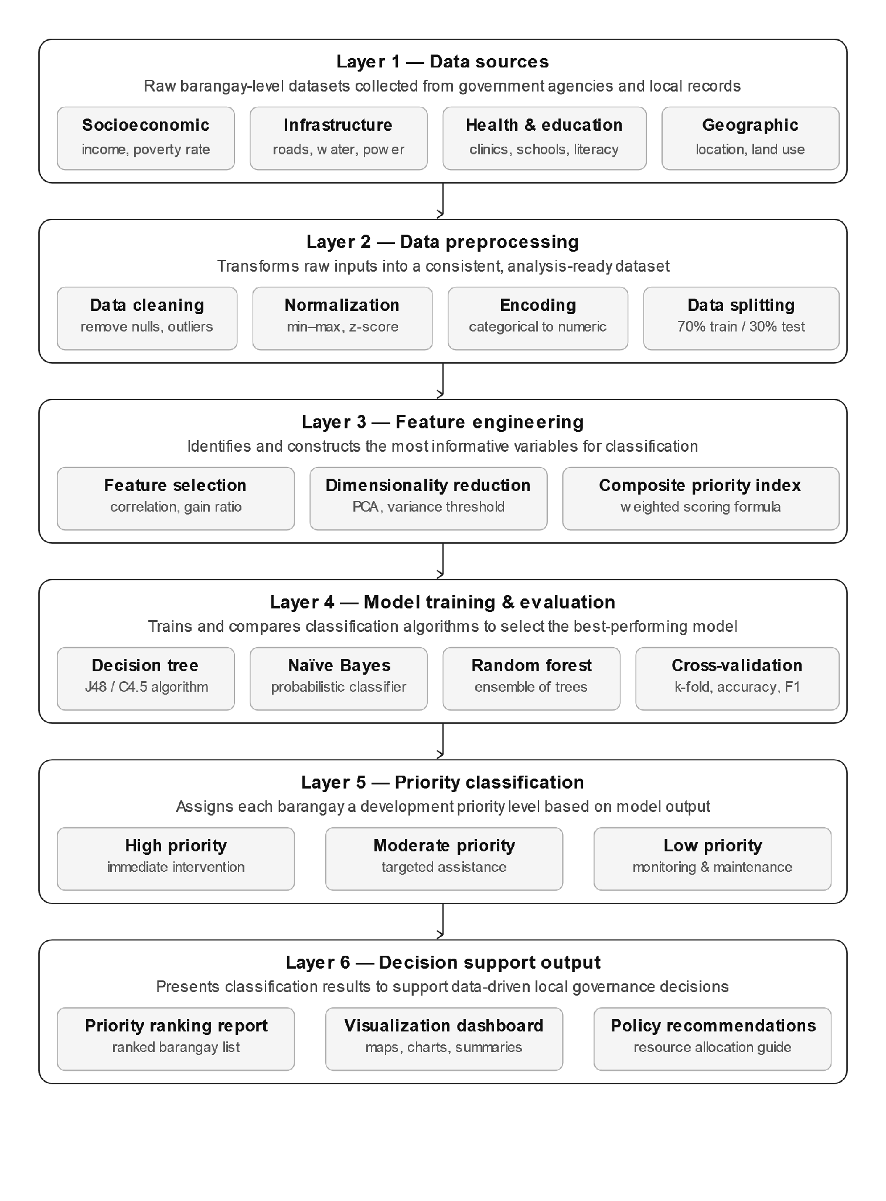
Figure 1. Data mining architecture for barangay priority classification

Data Preparation and Preprocessing
Before selecting the features and training the model, data preparation will happen. This includes checking for any missing data, duplicate entries, inconsistent labeling, invalid information and any outliers in the current dataset. The imputation of any missing values using the median for numerical data and the most prevalent (or mode) value for categorical data will be determined based on the distribution and type of the variable. Categorical variables will be changed to numbers via label encoding or made into 1s and 0s by one-hot encoding if the algorithm calls for it. All numerical data will either be scaled or transformed because algorithms like SVM are sensitive to how large or small those measurements are in comparison to other measurements. The process of data preprocessing helps establish that the incoming data for use with machine learning is set up properly.
Feature Selection Model Applied
This research utilizes the SelectKBest feature selection approach with mutual information classification scores in order to find the best-performing “k” number of features that can be used as input(s) into detailed classification systems. The purpose for using mutual information in association with SelectKBest feature selection is to quantify how much information a predictor variable contributes toward accurately classifying the target class (scikit-learn, 2026b; scikit-learn, 2026c). Features that have low mutual information scores can be omitted from the feature set in order to reduce excess noise in classification systems, and thus improve model performance. The value of “k” will depend upon the size of the dataset used for validation purposes and the importance of retaining meaningful predictor variables for the LGU’s reference.

Classification Models and Selected Primary Model
This study will utilize Decision Trees, Random Forests, Naive Bayes and Support Vector Machines, which are all forms of classification algorithms, as comparative benchmarks when assessing the performance of the classifications. Decision Trees allow for interpretation of results; Naive Bayes serves as a baseline from which it can be determined whether the classifications being made probabilistically are performing at expected levels; Support Vector Machines (SVM) allow for testing the ability to separate classes in higher dimensional space based on features of the dataset. The primary classification model that will be chosen is the Random Forest Classifier (Breiman, 2001). The choice of Random Forests is due to their ability to create an ensemble of decision trees that results in increasing the predictive accuracy of the Random Forester's by reducing the overfitting of an individual decision tree classifier (Scikit-learn developers, 2026d). Therefore, Random Forest is appropriate for this study because the dataset contains multiple socio-economic, infrastructure, and disaster-related indicators that may interact in determining barangay priority level.

Table 4. Classification models and selected primary model

Classification Model | Role in the Study | Justification
Decision Tree Classifier | Benchmark model | Interpretable rule-based classification; useful for explaining decision paths.
Random Forest Classifier | Selected primary model | Ensemble classification; expected to improve accuracy and reduce overfitting.
Naive Bayes | Benchmark model | Fast probabilistic classifier; useful as a simple baseline.
Support Vector Machine | Benchmark model | Useful for testing class boundaries in higher-dimensional feature space.

Model Training and Testing
In this study, the dataset will be divided into two parts (training and testing) with an 80/20 distribution. The training part will be used for training purposes and the testing part will be used to evaluate how well the model performs on new information that wasn't previously used in the training process. As stated in the scikit-learn documentation, train_test_split is a utility that randomly divides an array or matrix into two sets of randomly selected records (scikit-learn developers, 2026e). In order to account for imbalances in the number of occurrences between different classes, when splitting into these two sets, stratification will be used and any class ratio will remain constant for both the training and test datasets. Also, it may be possible to use cross-validation to verify whether or not the models being created produce the same performance or accuracy when applied to different datasets within the training or testing dataset.
Model Evaluation Metrics
The evaluation of all the models will occur through their performance being measured by various metrics, including (but not limited to): Accuracy, Precision, Recall, F1 Score, and Confusion Matrix. The Scikit-learn API provides classification metrics to estimate the performance of the model in predicting categories and provides a classification report that calculates Precision, Recall, F-Measures, and Support for every classification. (scikit-learn developers, 2026f; scikit-learn developers, 2026g).

Table 5. Model evaluation metrics
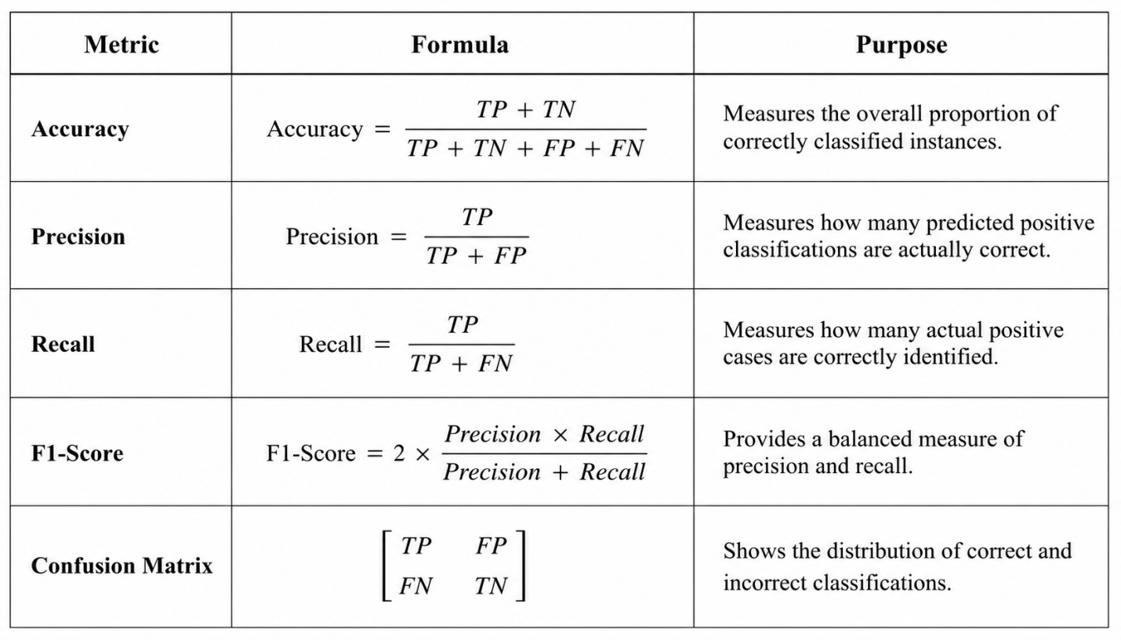
Model Comparison and Selection
Evaluations of all models will be based on the accuracy, precision, recall, F1-score, and confusion matrix results. Due to the focus on finding high priority barangays, most attention will be devoted to the recall and F1-scores of the High Priority class. A model that does not recognize high priority barangays will be less useful for LGU planning purposes, even if it has an acceptable overall level of accuracy.

While Random Forest is the current primary selection for a model, the ultimate acceptance of this model will be based on the results of the evaluation process. If another model produces significantly better results that are also easier to interpret, it will be documented and explained in detail. This methodology provides support for the methodology used to select a model and gives empirical proof of the validity of the final result.

Output and Interpretation
The study will ultimately produce a classification of the barangays as being of either High, Moderate or Low Priority base on each barangay's characteristics. The outputs of the model will be made available in tabular form, graphical representations and/or visual dashboards to facilitate ease of interpretation by LGUs. The model will also include Feature Importance/Selected Feature scores indicating which indicators had the greatest impact on the Priority classification. The Priority classification output is to be interpreted as a decision-support tool for LGU officials to validate their findings based on the model outputs, to conduct field checks, perform community consultations and develop resource allocation plans.
Ethical Considerations and Data Privacy
Anonymized, barangay-level data will be used in this research and personal identifiers will not be collected. All datasets that have personal and/or sensitive information must have the data anonymized prior to use in an analysis. The Data Privacy Act of 2012 protects the privacy of individuals and encourages innovation and growth by allowing personal information to flow freely between information systems while providing for the protection of those individuals' personal information (Republic Act No. 10173, 2012). Researchers will ensure that models are employed in a responsible manner and outputs provided by them are reviewed before being used for community development decisions so that those outputs can be reviewed by qualified LGU personnel and any limitations or biases inherent in the dataset are identified prior to providing community development assistance based on those outputs.

Tools and Software

Table 6. Tools and software used in the study

Tool/Software | Purpose
Python | Main programming language for data preparation, feature selection, and modeling.
Pandas and NumPy | Data cleaning, transformation, and tabular data handling.
Scikit-learn | Implementation of SelectKBest, mutual information scoring, train-test split, Random Forest, Decision Tree, Naive Bayes, SVM, and evaluation metrics.
Google Colab or Jupyter Notebook | Development environment for coding and model testing.
Power BI, Tableau, or Excel | Visualization and presentation of classification outputs.

Research Flow
1. Identify & define the Barangay prioritization problem and target class
2. Collect barangay level datasets from Local Government Units (LGUs) and other appropriate official sources.
3. Review and validate dataset items such as socio-economic, infrastructure, and disaster vulnerability indicators.
4. Clean up the dataset by addressing the missing value, duplicates, inconsistent entry, and invalid label issues.
5. Encode categorical variables and scale numerical variables as necessary.
6. Use Mutual Information scoring on SelectKBest to identify feature relevance.
7. Split the dataset into training & testing datasets with an 80:20 ratio and stratification if needed.
8. Train Decision Tree, Random Forest, Naive Bayes, and Support Vector Machine (SVM) models.
9. Evaluate models based on accuracy, precision, recall, F1 Score, and Confusion Matrix.
10. Choose the model that performed the best during evaluation. Choose Random Forest model as the preferred model unless the evaluation result indicates otherwise.
11. Generate Priority Barangays Classification and Decision Support (Insights) for Local Government Unit (LGU) Planning.

REFERENCES
Abid-Althaqafi, N. R., & Alsalamah, H. A. (2024). The effect of feature selection on the accuracy of X-platform user credibility detection with supervised machine learning. Electronics, 13(1), 205. https://doi.org/10.3390/electronics13010205
Al-Kahtani, N., Alruwaie, S., Al-Zahrani, B. M., Abumadini, R. A., Aljaafary, A., Hariri, B., Alissa, K., Alakrawi, Z., & Alumran, A. (2022). Digital health transformation in Saudi Arabia: A cross-sectional analysis using Healthcare Information and Management Systems Society’ digital health indicators. DIGITAL HEALTH, 8(1), 205520762211177. https://doi.org/10.1177/20552076221117742
Alsharkawi, A., Al-Fetyani, M., Dawas, M., Saadeh, H., & Alyaman, M. (2021). Poverty classification using machine learning: The case of Jordan. Sustainability, 13(3), 1412.
https://doi.org/10.3390/su13031412
Atta-Aidoo, J., & Antwi-Agyei, P. (2025). Climate-smart agriculture adoption in rural Ghana: do resource requirements matter? BMC Environmental Science, 2(1). https://doi.org/10.1186/s44329-025-00018-6
Breiman, L. (2001). Random Forests. Machine Learning, 45(1), 5–32.

Cortes, C., & Vapnik, V. (1995). Support-vector networks. Machine Learning, 20, 273-297. https://doi.org/10.1007/BF00994018
Feng, Y., & Park, J. (2026). Identifying and predicting key industry–education integration projects via explainable artificial intelligence (XAI) based machine learning models. PeerJ Computer Science, 12, e3868. https://peerj.com/articles/cs-3868.pdf
Gomez, R. C., & Santos, M. L. (2025). Developing data-driven decision support tools: Machine learning classification for municipal resource allocation. Philippine Journal of Computational Science and Public Policy, 3(2), 45–61.https://www.mdpi.com/2071-1050/13/3/1412
Haleem, P., Shafi, S., & Malik, M. A. (2023). A benchmark analysis of feature selection and machine learning methods for environmental datasets. BMC Bioinformatics, 24(1), 412.
https://doi.org/10.1186/s12859-023-05412-w
Han, J., Kamber, M., & Pei, J. (2012). Data mining: Concepts and techniques (3rd ed.). Morgan Kaufmann. https://www.sciencedirect.com/book/9780123814791/data-mining-concepts-and-techniques
IBM. (n.d.). CRISP-DM help overview. IBM Documentation. Retrieved May 14, 2026, from https://www.ibm.com/docs/pt-br/SS3RA7_sub/modeler_crispdm_ddita/clementine/crisp_help/crisp_overview.html
National Disaster Risk Reduction and Management Council. (2020). National Disaster Risk Reduction and Management Plan 2020-2030: Results-based monitoring and evaluation system. https://rbmes-api.ndrrmc.gov.ph/download/RBMES_NDRRMP_2020-2030.pdf
Nkurunziza, F., Kabanda, R., & McSharry, P. (2024). Enhancing poverty classification in developing countries through machine learning: A case study of household consumption prediction in Rwanda. Cogent Economics & Finance, 13(1), Article 2444374.: https://doi.org/10.1080/23322039.2024.2444374
Open Knowledge Repository. (2025). Worldbank.org. https://openknowledge.worldbank.org/entities/publication/18318a89-2668-402a-bf2a-ff1e966af398
Quinlan, J. R. (1986). Induction of decision trees. Machine Learning, 1, 81-106. https://doi.org/10.1007/BF00116251
Republic Act No. 7160, Local Government Code of 1991. (1991). https://lawphil.net/statutes/repacts/ra1991/ra_7160_1991.html
Republic Act No. 10173, Data Privacy Act of 2012. (2012). National Privacy Commission. https://privacy.gov.ph/data-privacy-act/
scikit-learn developers. (2026a). Support Vector Machines. In scikit-learn user guide. Retrieved May 14, 2026, from https://scikit-learn.org/stable/modules/svm.html
scikit-learn developers. (2026b). SelectKBest. In scikit-learn 1.8.0 documentation. Retrieved May 14, 2026, from https://scikit-learn.org/stable/modules/generated/sklearn.feature_selection.SelectKBest.html
scikit-learn developers. (2026c). mutual_info_classif. In scikit-learn 1.8.0 documentation. Retrieved May 14, 2026, from https://scikit-learn.org/stable/modules/generated/sklearn.feature_selection.mutual_info_classif.html
scikit-learn developers. (2026d). RandomForestClassifier. In scikit-learn 1.8.0 documentation. Retrieved May 14, 2026, from https://scikit-learn.org/stable/modules/generated/sklearn.ensemble.RandomForestClassifier.html
scikit-learn developers. (2026e). train_test_split. In scikit-learn 1.8.0 documentation. Retrieved May 14, 2026, from https://scikit-learn.org/stable/modules/generated/sklearn.model_selection.train_test_split.html
scikit-learn developers. (2026f). Metrics and scoring: Quantifying the quality of predictions. In scikit-learn user guide. Retrieved May 14, 2026, from https://scikit-learn.org/stable/modules/model_evaluation.html
scikit-learn developers. (2026g). classification_report. In scikit-learn 1.8.0 documentation. Retrieved May 14, 2026, from https://scikitlearn.org/stable/modules/generated/sklearn.metrics.classification_report.html
scikit-learn developers. (2026h). DecisionTreeClassifier. In scikit-learn 1.8.0 documentation. Retrieved May 14, 2026, from https://scikit-learn.org/stable/modules/generated/sklearn.tree.DecisionTreeClassifier.html
scikit-learn developers. (2026i). GaussianNB. In scikit-learn 1.8.0 documentation. Retrieved May 14, 2026, from https://scikit-learn.org/stable/modules/generated/sklearn.naive_bayes.GaussianNB.html
Supriyadi, S., Windarto, A. P., & Soemartono, T. (2024). A simple classification and clustering of poverty in rural areas using machine learning. Journal of Computer Science and Regional Analytics, 4(1), 15–29. https://doi.org/10.1016/j.seps.2024.101845 (Socio-Economic Planning Sciences alternative route)
United Nations Development Programme. (n.d.). Data for sustainable development. Retrieved May 14, 2026, from https://www.undp.org/digital-innovation/data-sustainable-development
van Ooijen, C., Ubaldi, B., & Welby, B. (2019). A data-driven public sector: Enabling the strategic use of data for productive, inclusive and trustworthy governance (OECD Working Papers on Public Governance No. 33). OECD Publishing. https://doi.org/10.1787/09ab162c-en
Okafor, C. U., & Diallo, A. M. (2024). Enhancing poverty and vulnerability classification in developing countries through multi-metric machine learning validation. Socio-Economic Planning Sciences, 95, 101920. https://doi.org/10.1016/j.seps.2024.101920
Onsay, E. A., & Rabajante, J. F. (2024). Measuring the unmeasurable multidimensional poverty for economic development: Datasets, algorithms, and models from the poorest region of Luzon, Philippines. Data in Brief, 53, 110150. https://doi.org/10.1016/j.dib.2024.110150
Pavlidis, G., & Charonyktakis, M. (2025). The role of mutual information estimator choice in feature selection: An empirical study on mRMR. Information, 16(9), 724. https://www.mdpi.com/2078-2489/16/9/724
Pradhan, N., & Agrawal, A. (2025). Mapping fine-scale socioeconomic inequality using machine learning and remotely sensed data. PNAS Nexus, 4(2). https://doi.org/10.1093/pnasnexus/pg

Appendix A



CURRICULUM VITAE

Name : Kevin John C. Catigador
Nickname : kj
Date of Birth : September 8, 2004
Home Address : San Rafael, Agusan del Sur
Citizenship : Filipino
Civil Status : Single
Sex : Male
Name of Father : Unknown
Name of Mother : Leah C. Castigador

Educational Background

Elementary : San Rafael Elementary School
Junior High School : Lucena National High School
Senior High School : Lucena National High School
Tertiary : Agusan del Sur State University
Course : Bachelor of Science in Information Systems

CURRICULUM VITAE


Personal Background

Name : Rey Anthony O. Lagonero
Nickname : TonTon
Date of Birth : August 5, 2004
Home Address : Santa. Josefa , Agusan del Sur
Citizenship : Filipino
Civil Status : Single
Sex : Male
Name of Father : Rey O. Lagonero
Name of Mother : Analyn O. Lagonero
Name of Brothers : Peter John Rey O. Lagonero
Name of Sister : Mary Anjielique O. Lagonero
: Niña Jean O. Lagonero

Educational Background

Elementary : Elementary School With Sped Program
Junior High School : National High School Sta. Josefa ADS
Senior High School : Senior High School Sta. Josefa ADS
Tertiary : Agusan del Sur State University
Course : Bachelor of Science in Information Systems

Appendix B

CRF 6


Figure 2. Castigador CRF 6


Figure 3.: Lagonero CRF 6

Appendix C

TURNITIN CERTIFICATE

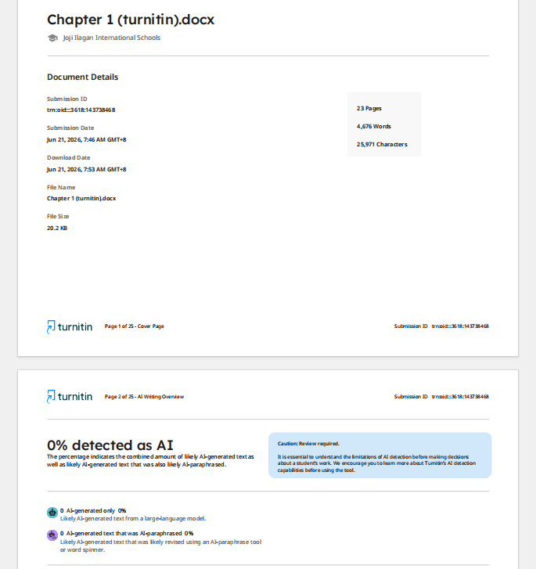
Figure 4.: Chapter 1 Turnitin Result
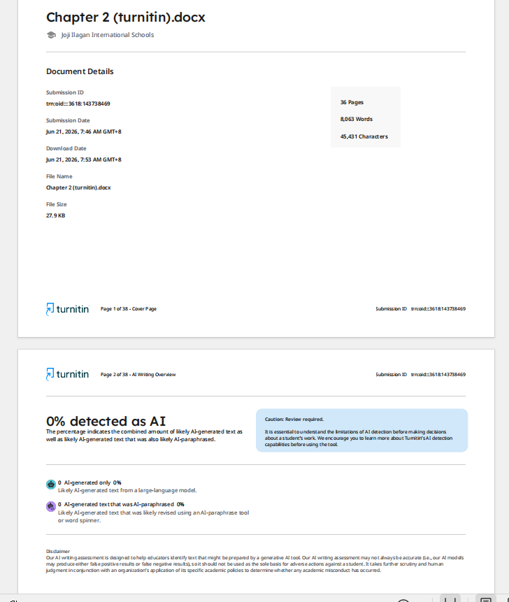
Figure 5.:Chapter 2 Turnitin Result

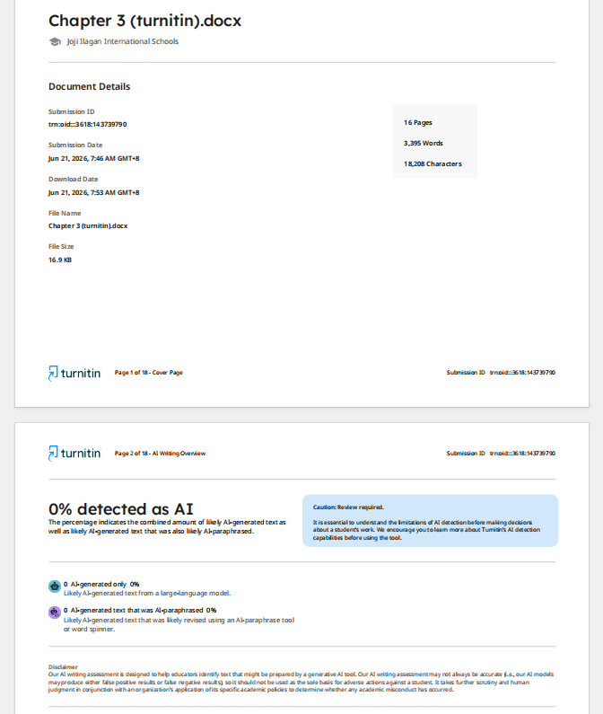
Figure 6.: Chapter 3 Turnitin Result

Appendix E
Grammarly Certificate

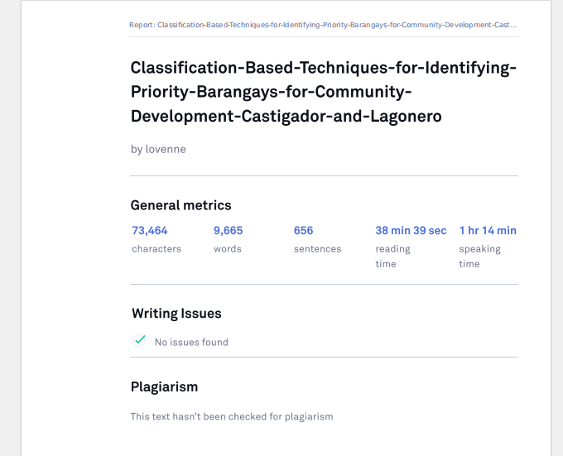
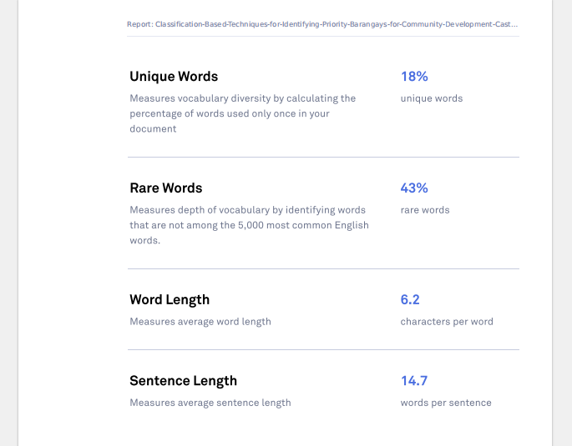
Figure 7.: Chapter 1-3 Grammarly Result

